FORM CLASS: ................................ NAME : ..........................................................…. …….

HOME PHONE: .............................................. MOBILE: ...............................………………….

HOME ADDRESS: ........................................................................................……………………

EMAIL ADDRESS:……………………………………………………………………………………...

NAMES OF PARENTS/CAREGIVERS: ..............................................................…………........

PARENTS’/CAREGIVERS’ EMAIL: ………………………………………………………………….

PNBHS and PNGHS PRE-AUDITION APPLICATION FORM FOR:
Please understand that in our pursuit of excellence, we are deadly serious about our expectations of commitment to our entire process of rehearsing and performing.
We make no apologies for that.
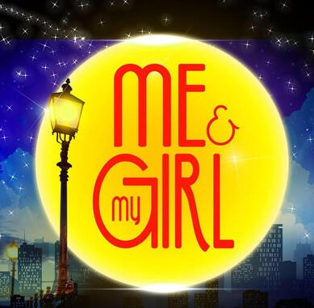

Enthusiasm and commitment are sometimes more important than experience, however, it can be useful to us to know any previous performing experience you may have. You may be asked to audition for, and may be cast in, any role. Please indicate below all areas you are particularly interested in (everyone will be required to sing and “move”):

Major/minor singing principal Major/minor singing principal understudy
Specialist Dancer Major/Minor non-singing principal Chorus
Major/Minor non-singing U/S Company Reps (Y12 or 13 in 2020)

Is there any reason why you might have difficulty attending the advertised rehearsals in Term 4 2019 or Term 1 2020? This may be taken into account should you ask for leave later.

………………………………………………………………………………………………………………………………………………

GOOD COMMUNICATION IS EVERYTHING
Commitment of auditionee AND parent/caregiver signatory:

In applying for an audition, WE have read the Pre-audition Information,

WE understand the commitments and WE agree that with the support of our family, the auditionee will:

- make Me and My Girl her/his number one co-curricular priority for
Term 1 2020 including jobs, church involvement, family activities and other sports/cultural activities or entertainment events. We understand that leave from any stage of the show has to be applied for from Mr Burton and that his decisions will be based on what is best for the team.
- attend all rehearsals she/he is scheduled for including Sundays in Term 4 and the first 2019 rehearsal on Sunday, January 27 12.30-5pm (and Thurs Jan 24 and Fri Jan 25 if he/she is a named role, dancer or understudy) barring emergencies, illness and school trips. In the event of one of these we will contact Mr Burton as soon as possible.
- be at rehearsal, ready to start at the advertised times
- from dress rehearsals onwards, hand in their mobile phone to staff at the company collection point, to be returned once the rehearsal/performance is over
- observe school rules in all activities associated with preparation and performance and other rules that may be set specifically for the show (including handing in his/her mobile phone for staff to store during dress rehearsals and performances)
- talk to a staff member asap and certainly before the end of the current school year if she/he experiences any difficulties in meeting expectations (Ms Kinsey-Wightman/Ms Joe/Ms Weston at PNGHS and Mr Burton/Mrs Clark/Ms Hughes at PNBHS)
Parents/caregivers – please note that in signing this document
you are confirming that
YOU and your son or daughter fully understand and accept the commitment to meet our expectations as above
and in the Pre-audition Information.

Signature of auditionee.............…………………….......……………….

Name of parent/caregiver.................................................Signature…………………………

If you or your parents/caregivers wish to discuss any aspect of the above, please contact
Mr Burton, before auditioning at burtonc@pnbhs.school.nz or 027 6237 395

Thankyou for your interest and enthusiasm. Get up! Get seen! Get heard!!
Production Management Team

