FORM CLASS: ................................ NAME : ..........................................................…. …….

HOME PHONE: .............................................. MOBILE: ...............................………………….

HOME ADDRESS: ........................................................................................……………………

EMAIL ADDRESS:……………………………………………………………………………………...

NAMES OF PARENTS/CAREGIVERS: ..............................................................…………........

PARENTS’/CAREGIVERS’ EMAIL: ………………………………………………………………….
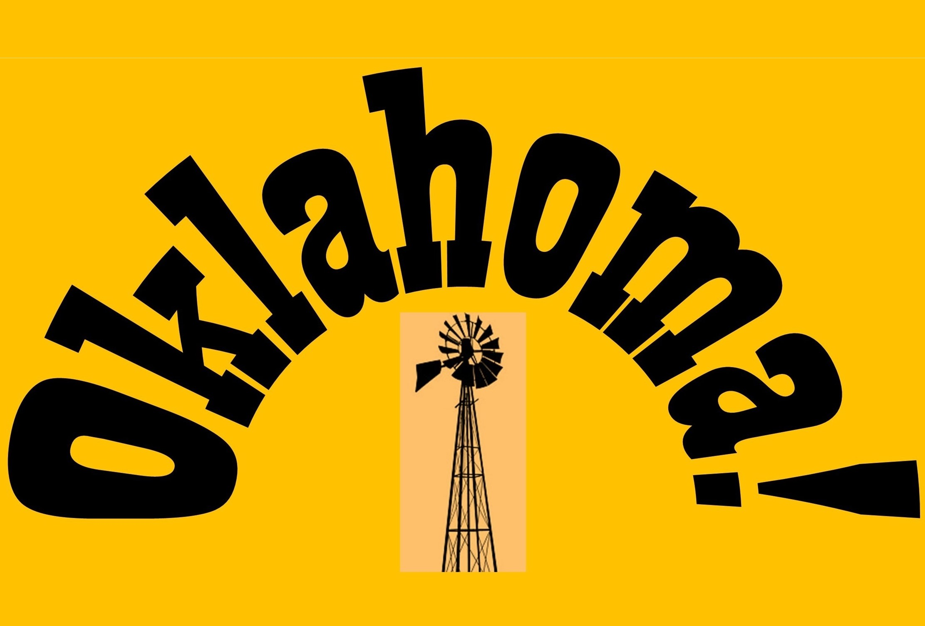

PNBHS and PNGHS CREW PRE-AUDITION APPLICATION FORM FOR:
Please understand that in our pursuit of excellence, we are deadly serious about our expectations of commitment to our entire process of rehearsing and performing.
We make no apologies for that.

Why do you want to be on the crew? __________________________________________________________________________________________________________________________________

What area(s) are you most interested in within the crew? (circle as many areas as you wish)

Sound Lighting Stage Crew Body Mics Props Front of House

Makeup/Hair Follow Spot (spotlight) Trainee Stage Manager/Head Mechanist

A Head of Department (must have experience)

Director’s Personal Assistant and Caller. This role begins in Term 1 Week 4 when full runs of the show commence. You would also be part of another Dept

Please list any past experience/skills you have in this/these area(s):

___________________________________________________________________________________________________________________________________________________________________________________________________

Do you have any health issues the management team should be aware of? YES/NO
If you have answered YES please attach the necessary information.
GOOD COMMUNICATION IS EVERYTHING
Commitment guarantee of auditionee AND parent/caregiver signatory:

In applying for an audition,
WE HAVE READ THE PRE-AUDITION INFORMATION,

WE understand the commitments and WE agree that with the support of our family, the auditionee will:

- make Oklahoma! their number one co-curricular priority for
Term 1 2022 including jobs, church involvement, family activities and other sports/cultural activities or entertainment events. We understand that leave from any stage of the show has to be applied for from Mr Burton and that his decisions will be based on what is best for the team.
- attend all rehearsals she/he is scheduled for including Sundays in Term 4 and the first 2022 full cast rehearsal on Sunday, January 30 12.30-5pm barring emergencies, illness and school trips. In the event of one of these we will contact Mr Burton as soon as possible.
- be at rehearsal, ready to start at the advertised times
- from dress rehearsals onwards, hand in their mobile phone to staff at the company collection point, to be returned once the rehearsal/performance is over
- observe school rules in all activities associated with preparation and performance including appropriate online behaviour, and other rules that may be set specifically for the show
- talk to a staff member asap if she/he experiences any difficulties in meeting expectations (Ms Joe/Ms Pomana-Whale at PNGHS and Mr Burton/Mrs Clark/Ms Hughes/Miss Belcher at PNBHS)
Parents/caregivers – please note that in signing this document
you are confirming that
YOU and your son or daughter fully understand and accept the commitment to meet our expectations as above
and in the Pre-audition Information.

Signature of auditionee.............…………………….......……………….

Name of parent/caregiver.................................................Signature…………………………

You submit this application to Mr Burton by email (below) or hard copy to the PNBHS Main Office. If you wish to discuss any aspect of the above, please contact The Production Manager,
Mr Burton, at burtonc@pnbhs.school.nz or 027 6237 395

Applications close at 430pm Friday October 29 (Term 4 Week 2).

Thankyou for your interest and enthusiasm. Production Management Team

